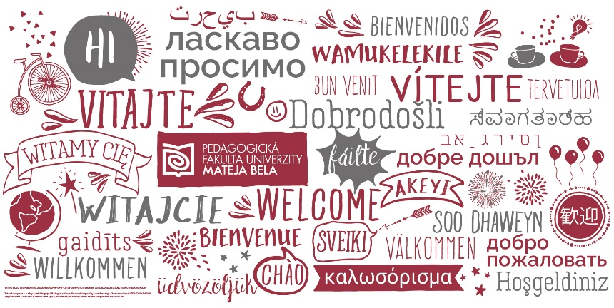

Do you want to learn to SPEAK in English?
Would you like to learn English naturally via meeting colleagues and people in local community?
Do you want to learn not only English, but about other cultures in a new way?
Would you like to combine learning languages, cultures and meaningful activity in a community

WELCOME TO GELS COURSE FOR 5 CREDITS
(GLobal Encounters in Local Settings 1)
for all MBU students and all Erasmus incoming students
1d-GELS1-511 Global Encounters in Local Settings1 (Bachelor students)
2d-GELS1-521 Global Encounters in Local Settings1 (Master students)
3d-GELS1-551 Global Encounters in Local Settings1 (PhD students)
PdF/MobGELS1 Global Encounters in Local Settings1 (Erasmus students)

How to sign in AIS for this course: Students from any faculty - you have to search this way:
- Open the academic year 2020/21 – WINTER TERM
- Open the Faculty of Education (Pedagogická fakulta), department of Pedagogy (Katedra pedagogiky)

In case of interest or any questions - write to: dana.hanesova@umb.sk.

